--------------------------------------------
VITYARTHI PROJECT
PROGRAMMING IN JAVA

Topic- Delta V calculator for Launching Rockets

Name- Ayushman Dash
Registation Number- 25BAS10028
Date of Submittion- 16th of September, 2026
Branch- Aerospace Engineering

--------------------------------------------

Introduction
In aerospace engineering, calculating total velocity change ($\Delta v$) is fundamental to launch vehicle design and mission planning. The rocket equation determines whether a spacecraft can overcome planetary gravitational potential and reach target orbits (such as Low Earth Orbit). This project provides a Java-based computational terminal tool that models single and multi-stage launch vehicle performance, evaluates mass ratios, and checks orbital insertion feasibility using Tsiolkovsky’s Rocket Equation.

Problem Statement
Launch vehicle performance evaluation requires complex sequential calculations across multiple stages, accounting for varying dry masses, propellant loads, specific impulses (sp), and payload constraints. Manual calculations are prone to errors when adjusting stage configurations. This project provides a reliable, crash-resilient application to automate multi-stage Delta v evaluation, validate structural payload limits, and determine orbital capability.

Functional Requirements
- FR-1: Vehicle Inventory Management: View and register single-stage or multi-stage rocket configurations dynamically.
- FR-2: Physics & Delta-V Computation Engine: Calculate stage-by-stage and cumulative $\Delta v$ using Tsiolkovsky's Rocket Equation.
- FR-3: Structural & Orbital Feasibility Check: Verify that payload mass does not exceed structural limits and compare cumulative Delta against the Low Earth Orbit (LEO) benchmark threshold of 9,300m/s.

Non-Functional Requirements
- NFR-1: Maintainability & Clean Architecture: A compact design limited to 4 core classes for modular readability without unnecessary code bloat.
- NFR-2: Error Handling & Robustness: Traps non-numeric and out-of-bounds user inputs using scanner buffer checks to prevent application crashes.
- NFR-3: Usability: Clear console UI with formatted tabular summaries for burn breakdowns.
- NFR-4: Performance & Efficiency: Real-time logarithmic processing with negligible execution latency 10 ms.

System Architecture & Class Descriptions
The application is structured into four core classes operating within a single default package:
- Stage Class (Data Model): Represents an individual rocket stage. It encapsulates attributes for stage number, dry mass (kg), propellant mass (kg), and specific impulse (sp) in seconds.
- Rocket Class (Domain Model): Represents a complete launch vehicle. It contains attributes for rocket ID, rocket name, maximum allowable payload mass, and a list of Stage objects representing the vehicle's propulsion steps.
- DeltaVCalculator Class (Physics Engine): Contains static physics constants (Standard Gravity,g = 9.80665 m/s²) and LEO Benchmark 9,300 m/s and houses the core mathematical algorithms to process stage burnout masses and compute logarithmic velocity changes.
- MainApp Class (Control & CLI): Serves as the main entry point (public static void main). It manages the command-line menu loop, initializes default vehicle data, accepts user selections, and handles input validation to catch terminal errors.

Execution & Program Workflow
The application execution follows a structured terminal-based control loop:
- Initialization: The program launches through MainApp.main() and seeds default launch vehicles (e.g., Saturn V) into memory.
- Menu Loop: The console presents an interactive 4-option menu:
  - Option 1 (View Fleet): Displays all currently stored launch vehicles along with their stage configurations and payload limits.
  - Option 2 (Add Rocket): Prompts the user to enter specs for a new vehicle, including structural payload constraints and stage-by-stage parameters.
  - Option 3 (Calculate Delta-V): Prompts for a Rocket ID and mission payload mass. The application validates the payload against structural limits, iteratively computes burnout for each stage, displays a detailed stage-by-stage breakdown, and evaluates LEO feasibility.
  - Option 4 (Exit): Terminate program execution safely.
- Input Validation: For all menu choices, input helper methods (readInt and readDouble) trap string inputs or negative numbers, re-prompting the user without crashing the application.

Design Decisions & Rationale
- Single-Package Structure: Constraining the codebase to 4 core classes (Stage, Rocket, DeltaVCalculator, MainApp) eliminates package overhead while maintaining clear separation of concerns (Models vs. Logic vs. UI).
- Composition Over Inheritance: Using a List<Stage> inside Rocket allows seamless support for both single-stage (SSTO) and multi-stage vehicles without needing complex subclass hierarchies.

Implementation Details
- Physics Equation: Implements Tsiolkovsky’s Rocket Equation:
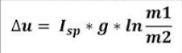

- Where m₀ is the total initial mass before stage ignition and m_{f} = m₀ - m_{propellant} is the remaining mass at stage burnout.
- Stage Burn Sequential Loop: Dynamically deducts stage dry mass as each stage burns out and is jettisoned before evaluating subsequent stages.

-----------------------------------------------------------------------------------------------------------------------------------------

Sample Terminal Results
Below is an example of the program's output during a calculation run:
This section includes the screenshots of all the test runs of the given program
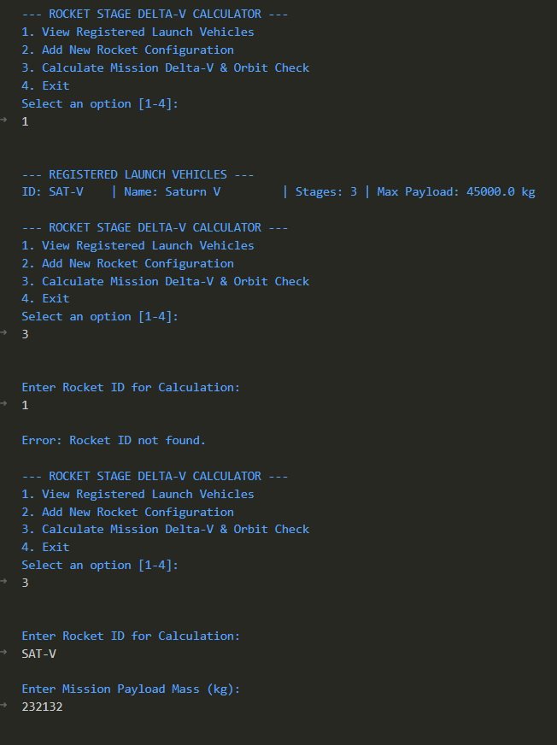
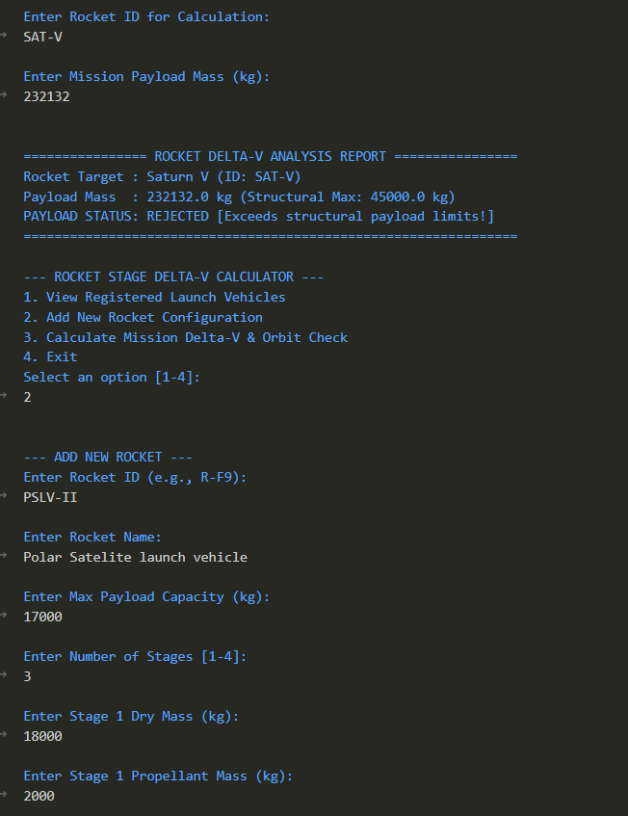

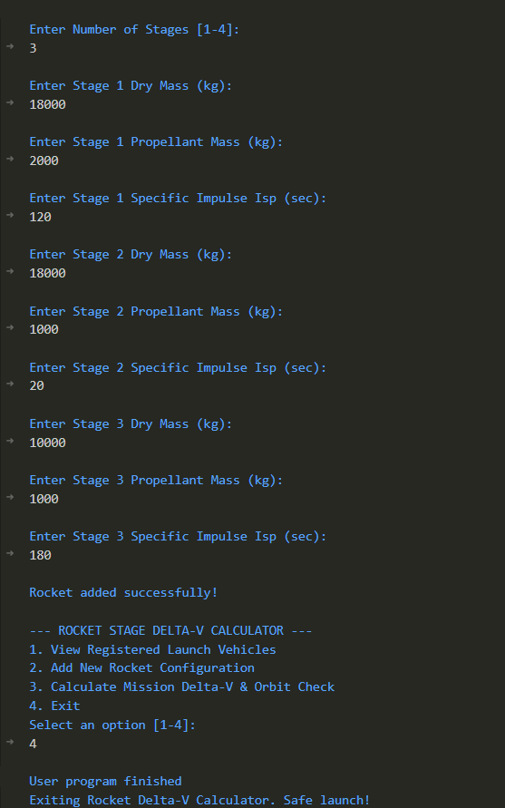

Testing Approach
Test Case | Input | Expected Output | Result
Valid Delta-V Computation | ID: SAT-V, Payload: 45000 | Displays stage breakdown and ORBITAL CAPABLE (LEO) | Passed
Overweight Payload | ID: SAT-V, Payload: 60000 | PAYLOAD STATUS: REJECTED [Exceeds structural limits!] | Passed
Invalid Terminal Input | Letters entered for decimal fields | Please enter a valid positive decimal number: prompt re-displays | Passed

Challenges Faced
- Scanner Buffer Trapping: Consuming lingering newline characters (\n) after reading numerical values using scanner.nextInt() to prevent menu loop skip errors.
- Sequential Mass Decay Modeling: Ensuring payload mass remains attached while discarded stage dry mass is properly subtracted from total mass ($m_0$) in subsequent stage iterations.

Learnings & Key Takeaways
- Mastered Java's Math.log() function for natural logarithm applications in aerospace physics.
- Gained practical experience managing dynamic collections (ArrayList) of custom objects.
- Understood robust console input validation strategies using conditional loops.

Future Enhancements
- Integrate a Graphical User Interface (GUI) using JavaFX or Swing for interactive visual graphs.
- Add dynamic atmospheric drag and gravity loss factors to improve $\Delta v$ accuracy.

References
- Tsiolkovsky, K. E. (1903). The Exploration of Cosmic Space by Means of Reaction Devices.
- Oracle Corporation. Java SE 17 Developer Documentation.

